[Animated Like Button (codepen.io)](https://codepen.io/kieranfivestars/pen/PwzjgN)

[Twitter [Like button] in HTML5/SVG & CSS3 Animations (codepen.io)](https://codepen.io/robeen/pen/PbvJjy)

[Hovers and focus using the has() relational pseudo-class (codepen.io)](https://codepen.io/utilitybend/pen/bGvjLba) das isch de Charte wo ich benützt han.

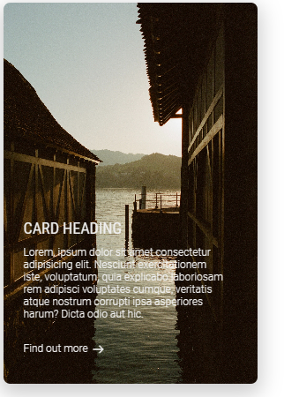

[Simple Animated Card (codepen.io)](https://codepen.io/jepooley/pen/NWYryap)